Question #1

*Write a Bourne shell script lastarg, which takes 0 or more arguments and prints the last (rightmost) argument in the argument list. You can assume that arguments will be made up of letters and digits only.*

Program:

**#!/bin/sh** #initializing shell script

**args=${!#}** #defining args as last entered argument

**echo $args** #printing args.

*If lastarg is placed in your home directory, what will happen if you execute the following command? Explain why you got this output.*

* **cd; lastarg .\***

Input:

**obelix[22]% cd;**

**obelix[23]% sh lastarg .\***

Output:

**.xsession.14-09-11**

* When using the following commands lastarg will print out a hidden file in the home directory. This happens because the program will process all the hidden files and print out the last entered.

|  |  |  |
| --- | --- | --- |
| Test Cases | Input | Output |
| #1 | obelix[11]% sh lastarg | lastarg |
| #2 | obelix[13]% sh lastarg arg1 arg2 arg3 arg4 arg5 arg6 arg7 arg8 arg9 arg10 arg11 | arg11 |
| #3 | obelix[16]% sh lastarg 01230ofowei 0390 ijww9 9i09i3dii | 9i09i3dii |

Question #2

*Write a Bourne shell script odd_prn, which echoes its shell script file name as well as the values of its odd arguments. Even arguments should be ignored. Each value should be echoed in a separate line. You can assume that arguments will be made up of letters and digits only****.***

Program:

**#!/bin/sh**

**X=$0**

**echo $X**

#setting x to position zero so it will output program if no arguments follow

#printing $X which will be all arguments that meet condition

**while [ $# -gt 0 ]; do**

**X=$1**

**echo $X**

#while loop sets condition that position must be greater then zero

#set X to position one to print

#print position X which will be the first position

#two shifts will replace position $1 with Position $3 and continue to print position $1 until no arguments are left.

#this will print all odd arguments because of the double shift.

**shift**

**shift**

**done**

|  |  |  |
| --- | --- | --- |
| Test Case | Input | Output |
| #1 | obelix[17]% bash odd_prn | odd_prn |
| #2 | obelix[18]% bash odd_prn 1 2 3 4 5 6 7 8 9 | odd_prn  1  3  5  7  9 |
| #3 | obelix[19]% bash odd_prn sdasd 1212e dq 3 2d 23d23d2 322d | odd_prn  sdasd  dq  2d  322d |
| #4 | obelix[20]% bash odd_prn arg1 arg2 arg3 arg4 arg5 arg6 arg7 arg8 arg9 arg10 arg11 | odd_prn  arg1  arg3  arg5  arg7  arg9  arg11 |

*If odd_prn is placed in your home directory, what will happen if you execute the following command? Explain why you got this output.*

* **cd; odd_prn .\***

Input:

**obelix[12]% cd;**

**obelix[13]% bash odd_prn .\***

Output:

**odd_prn**

**.**

**.ICEauthority**

**.Xauthority**

**.alias.rs6000**

**.alias.sun4m**

**.cache**

**.cshrc**

**.dmrc**

**.emacs**

**.forward**

**.gconfd**

**.gnome2**

**.gnupg**

**.history.x86_64-linux**

**.login**

**.mwmrc**

**.plan**

**.recently-used**

**.ssh**

**.thunderbird**

**.viminfo**

**.xsession**

**.xsession.14-09-11**

* By using the commands above, assuming odd_prn is in the home directory, it will collect all hidden files in the directory and then output every item in position $1. After running through the program and shifting each item, to continue to output every odd positioned item, until no files are left.

Question 3

*Draw a flow chart and write a Bourne shell script that causes the following output (below) to be displayed. Note that, there is a single space between each value. The number of column should be taken as an input during execution.*

**Flow Chart:**

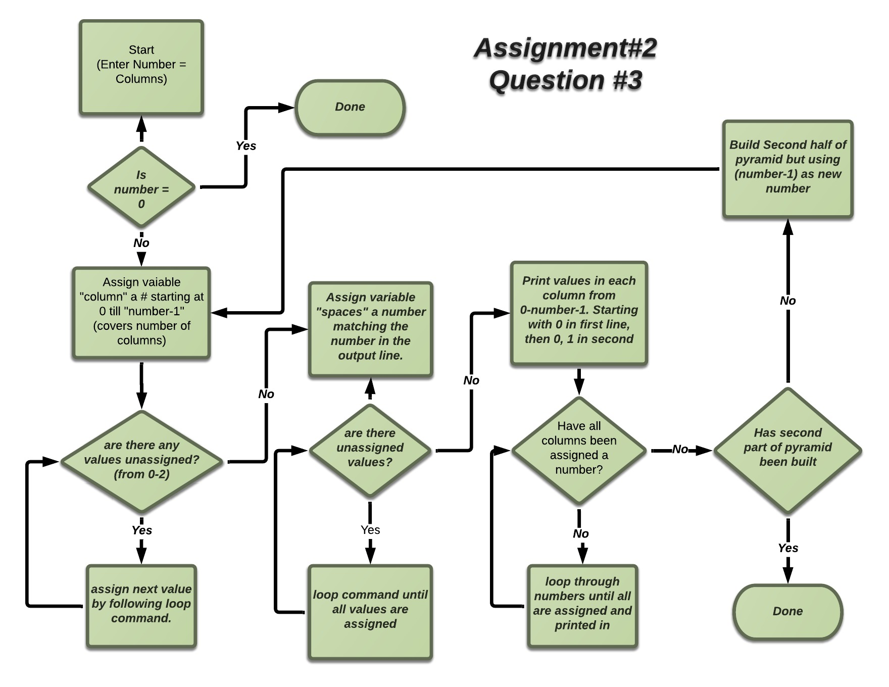

Program:

**#!/bin/bash**

#Taking input the number is how many columns will be created

**echo "Enter Number:"**

**read number**

#Outer loop for printing number of column in first half of pyramid

**for((column=0;** **column<=number-1;** **column++))**

**do**

#Loop for printing required spaces of first half of pyramid

**for((spaces=0;spaces<=number; spaces++))**

**do**

**echo -ne " "**

**done**

#Loop for printing 1st part of pyramid

**for((j=0;j<=column; j++))**

**do**

**echo -ne "$j "**

**done**

**echo**

**done**

#Outer loop for printing number of rows 2nd part in pyramid

**for((column2=column-1;** **column2>=0;** **column2--))**

**do**

#Loop for printing required spaces second half of pyramid

**for((spaces2=number;spaces2>=0; spaces2--))**

**do**

**echo -ne " "**

**done**

#Loop for printing 2nd part of pyramid

**for((i=0;i<=(column2-1); i++))**

**do**

**echo -ne "$i "**

**done**

#echo for printing new line

**echo**

**done**

|  |  |  |
| --- | --- | --- |
| Test Cases | Input | Output |
| #1 | obelix[12]% bash pyramid  Enter Number:  6 | 0  0 1  0 1 2  0 1 2 3  0 1 2 3 4  0 1 2 3 4 5  0 1 2 3 4  0 1 2 3  0 1 2  0 1  0 |
| #2 | obelix[14]% bash pyramid  Enter Number:  3 | 0  0 1  0 1 2  0 1  0 |
| #4 | Obelix[15]% bash pyramid  Enter Number:  0 | (no output) |

Question #4

Flow Chart

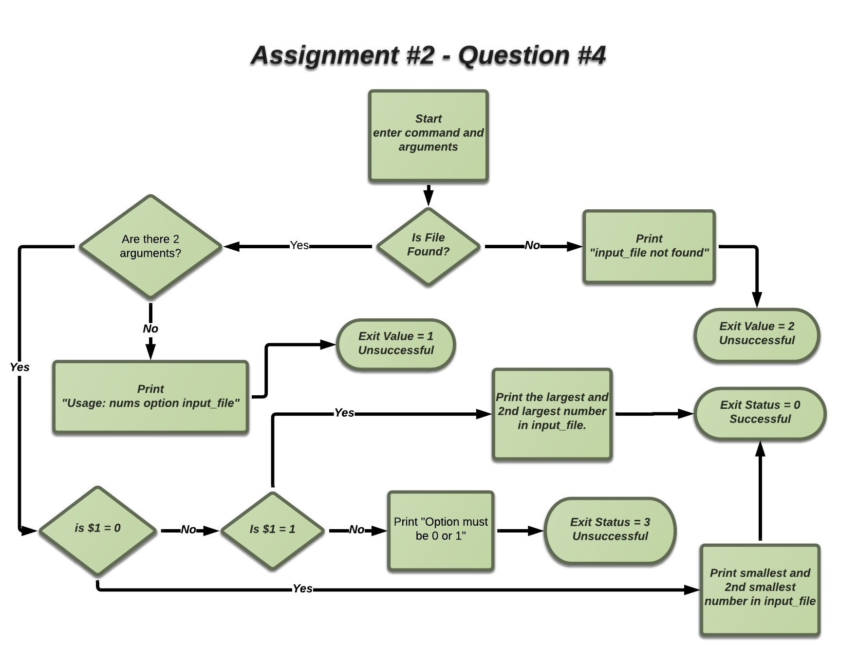

Program

**#!/bin/bash**

#checks to see that there are no more then 2 arguments

**if [ "$#" -gt 2 ];then**

**echo "Usage: nums option input_file"**

**exit 1**

**fi**

#checks to see that there are no less then 2 arguments

**if [ "$#" -lt 2 ];then**

**echo "Usage: nums option input_file"**

**exit 1**

**fi**

#checks to see that the file exists

**if [ ! -s "$2" ];then**

**echo "input_file not found."**

**exit 2**

**fi**

#checks to see that the option entered is 0 or 1

**if [ "$1" -gt 1 ];then**

**echo "Option must be 0 or 1"**

**exit 3**

**fi**

#if parameters are all correct and option is 0 then sort file smallest to greatest and print first two lines

**if [ "$1" -eq 0 ];then**

**sort -nk1 $2 | head -2**

**exit 0**

**fi**

##if parameters are all correct and option is 1 then sort file greatest to smallest and print first two lines

**if [ "$1" -eq 1 ];then**

**sort -rnk1 $2 | head -2**

**exit 0**

**fi**

|  |  |  |
| --- | --- | --- |
| Test Case | Input | Output |
| #1 | obelix[15]% bash nums  obelix[16]% echo $? | Usage: nums option input_file  1 |
| #2 | obelix[17]% bash nums 0  obelix[18]% echo $? | Usage: nums option input_file  1 |
| #3 | obelix[19]% bash nums 5  obelix[20]% echo $? | Usage: nums option input_file  1 |
| #4 | obelix[21]% bash nums 0 numbersfile  obelix[22]% echo $? | -10  -8  0 |
| #5 | obelix[23]% bash nums 1 numbersfile  obelix[24]% echo $? | 16  11  0 |
| #6 | obelix[25]% bash nums numbersfile  obelix[26]% echo $? | Usage: nums option input_file  1 |
| #7 | obelix[27]% bash nums 5 numbersfile  obelix[28]% echo $? | Option must be 0 or 1  3 |
| #8 | obelix[29]% bash nums 0 numbersfile aaaa  obelix[30]% echo $? | Usage: nums option input_file  1 |
| #10 | obelix[31]% bash nums 0 aaaa  obelix[32]% echo $? | input_file not found.  2 |
| #11 | obelix[33]% bash nums 0 bbbb  obelix[34]% echo $? | input_file not found.  2 |